

Creating   
Slideshow Videos

Scripture App Builder:

Creating Slideshow Videos

© 2022, SIL International

31 August 2022

You are free to print this manual for personal use and for training workshops.

The latest version is available at

<http://software.sil.org/scriptureappbuilder/resources/>

and on the Help menu of Scripture App Builder.

**Contents**

1. Introducing slideshow videos 4

1.1. What are slideshow videos? 4

1.2. What resources do I need to create a slideshow video? 5

1.3. What slideshow templates are currently available? 5

2. Setting up slideshow videos 6

2.1. Downloading slideshow video templates 6

2.2. Installing LibreOffice 7

3. Preparing an app project for slideshow videos 7

4. Running the Create Slideshow Wizard 8

5. Distributing and using the videos 10

# Introducing slideshow videos

## What are slideshow videos?

Slideshow videos are videos created using a set of still images together with audio files from a *Scripture App Builder* project. While the audio plays, the images will pan and/or zoom. Subtitles will be generated from the text in the app.

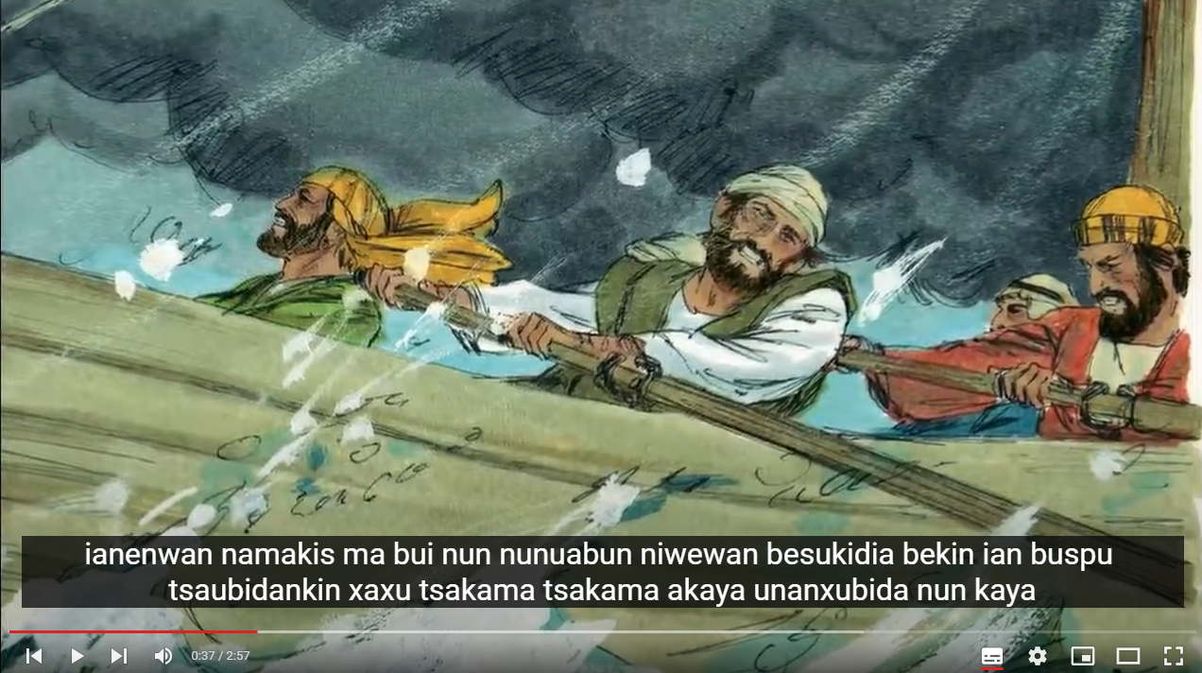

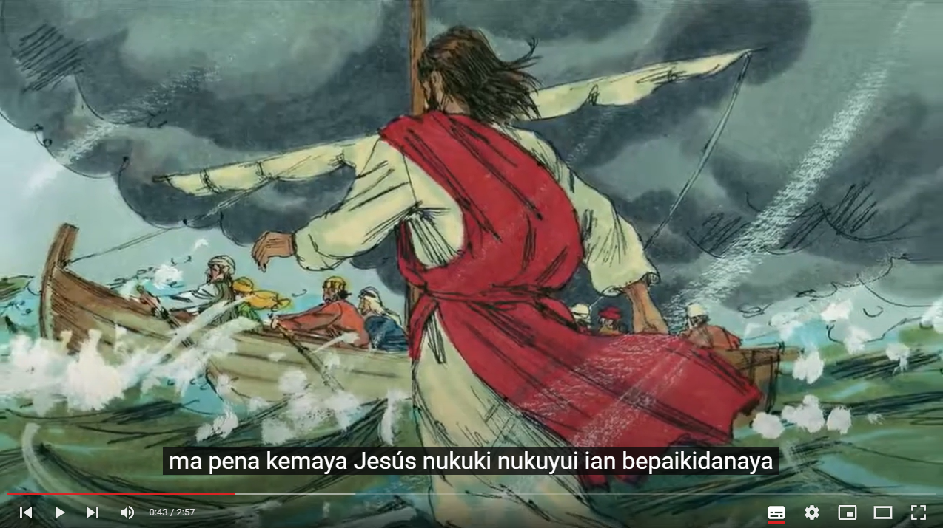

[Jesus calms the storm – in the Juni Kuin language of Peru](https://www.youtube.com/watch?v=oY3BrpoVbGI&list=PLoDMmx9LIxpPcT2qrXQXAkda5pcvuWIdh)

The videos are MP4 files which can be shared with others, uploaded to YouTube or Vimeo, or integrated within a Scripture app.

## What resources do I need to create a slideshow video?

You will need:

* A Scripture App Builder **app project with audio and timing files**.
* A set of predefined **slideshow video templates**: we will show you how to obtain these in the next section. They contain all the images for the video, together with instructions on which portions of Scripture to use, where to pan and zoom and where to move from one slide to another.

## What slideshow templates are currently available?

Available slideshow video templates include:

|  |  |
| --- | --- |
| Matthew | 3 videos (selected stories) |
| Mark | 9 videos (selected stories) |
| Luke | 6 videos (selected stories) |
| John | 43 videos (complete book) |
| Acts | 4 videos (selected stories) |
| Jonah | 1 video |

# Setting up slideshow videos

Before you create your first video, you will need to do two things:

1. Download the slideshow video templates.
2. Install LibreOffice.

## Downloading slideshow video templates

The video templates contain sets of images for each video, together with instructions on which portions of Scripture to use, where to pan and zoom and where to move from one slide to another.

To download the templates:

1. In Scripture App Builder, go to **Tools** ⮚ **Settings** ⮚ **Slideshows**   
   (or if using a Mac, Scripture App Builder ⮚ Preferences ⮚ Slideshows)

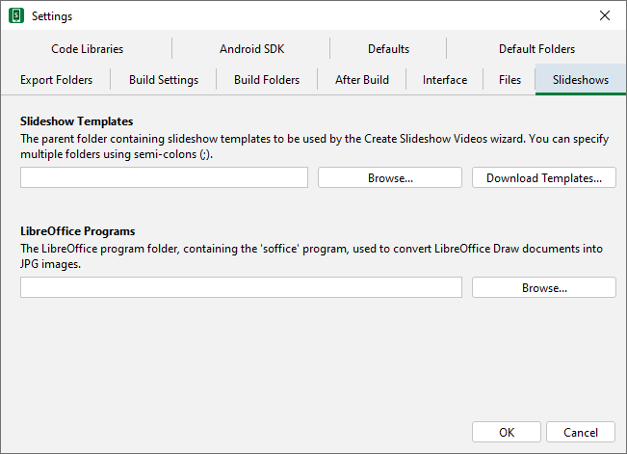

1. Click the **Download Templates…** button.

The installation process will allow you to set the folder where the templates will be located on your computer. Once installed, this folder will appear in the **Slideshow Templates** settings.

## Installing LibreOffice

*LibreOffice* will be used to create the title slides in each video.

1. Install *LibreOffice* from [https://www.libreoffice.org/download](https://www.libreoffice.org/download/download-libreoffice/)
2. In Scripture App Builder, go to **Tools** ⮚ **Settings** ⮚ **Slideshows** (or if using a Mac, Scripture App Builder ⮚ Preferences ⮚ Slideshows).
3. Under **LibreOffice Programs**, specify where the LibreOffice program is located on your computer.

# Preparing an app project for slideshow videos

The videos will contain images that pan and zoom while the audio is played. Since the audio is extracted from the project audio and timing files, it is important that the timing files are accurate so that the videos do not begin or end in the middle of an audio phrase.

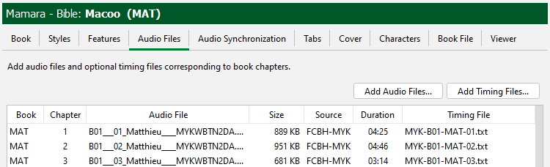

The transitions between slides are not as critical, but the timing accuracy is particularly important at the start and the end of a video. For example, if you are making a video on the Visit of the Magi (Matthew 2:1-23), you will need to make sure that the timings are accurate for the start of verse 1 and the end of verse 23.

Use **Fine Tune Timings** to verify that the timings are correct.

# Running the Create Slideshow Wizard

To use the Create Slideshow Wizard to make a video:

1. Right-click on a book collection and select **Create Slideshow Videos…**

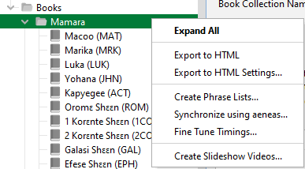

1. Select the videos from the list that you want to build.

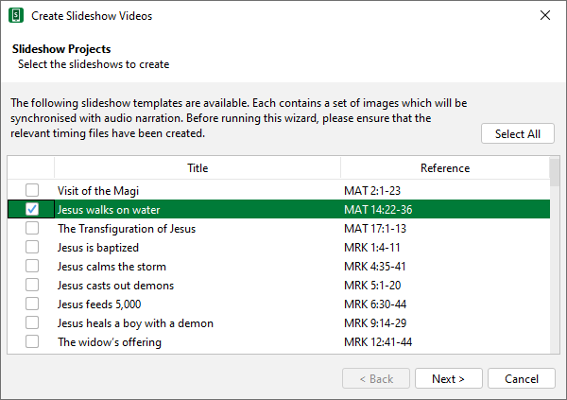

1. Click **Next** and specify the **Titles Language**, **Language Name** and **Country**.
2. Click **Next** and specify the **Language Code**, text and audio **Copyright** information.

The Text and Audio copyright information will be inserted automatically from the **Copyright & Licensing** tab if it is already specified in the app project. It can be to edited here too. This information will be included in the video title and final copyright slides.

1. Click **Next** and then the **Create Slideshows** button.

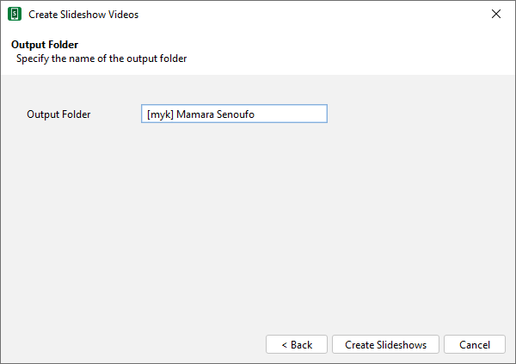

1. Wait while the video is compiled. This will include extracting the audio, adding the images, applying the pan and zoom effects and creating the subtitles.

When the videos have been created, you will find a subfolder corresponding to each video.

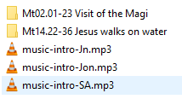 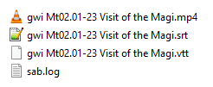

Each video subfolder will contain:

* a **video file** (.mp4)
* the corresponding **subtitle files** (.srt and .vtt). These can be used in video players such as *VLC* or for uploading to *YouTube* to make the text available as subtitles.

# Distributing and using the videos

There are many ways of distributing your videos, such as:

* Uploading them to a video sharing platform such as YouTube or Vimeo.
* Making them available on a language-specific website, or a site with multiple language resources such as Scripture Earth ([www.ScriptureEarth.org](http://www.ScriptureEarth.org))
* Sharing them from phone to phone using Bluetooth or a Wi-Fi transfer app
* Sharing them on memory cards
* Making them available on a Wi-Fi media hub

Once the videos are available in *YouTube* or another internet location, you can embed them in your apps. For more information on how to do this, please refer to the **Building Apps** manual, in the section titled **Video**.

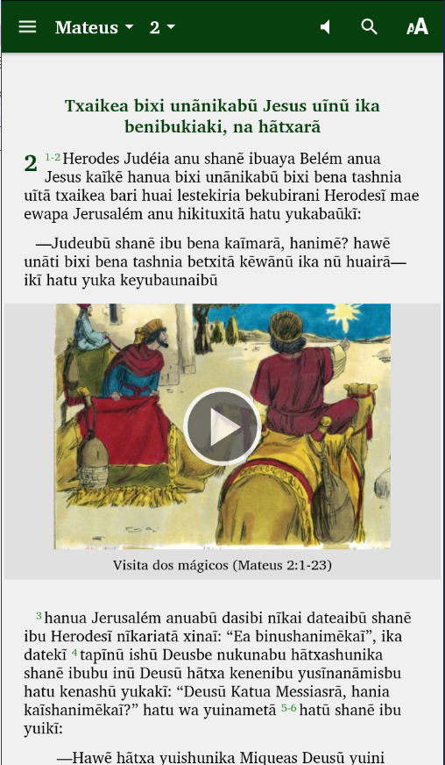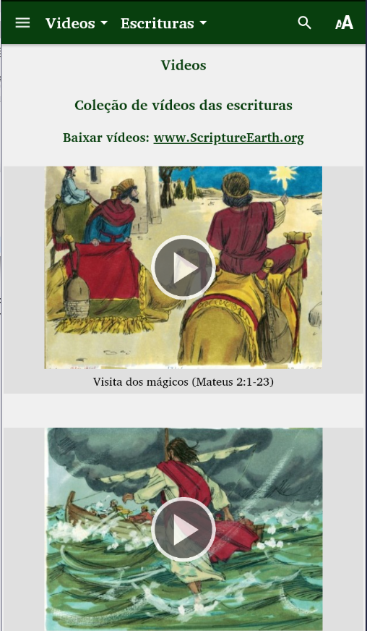

[www.ScriptureEarth.org](http://www.ScriptureEarth.org) can host the video files for viewing or downloading. Please contact [info@ScriptureEarth.org](mailto:info@ScriptureEarth.org) for more information.

Scripture Earth Example

Here is an example of what it looks like when a set of slideshow videos are uploaded to Scripture Earth:

<https://www.scriptureearth.org/00i-Scripture_Index.php?idx=22>.

Click on **View Videos de las Escrituras** to view the list of videos.

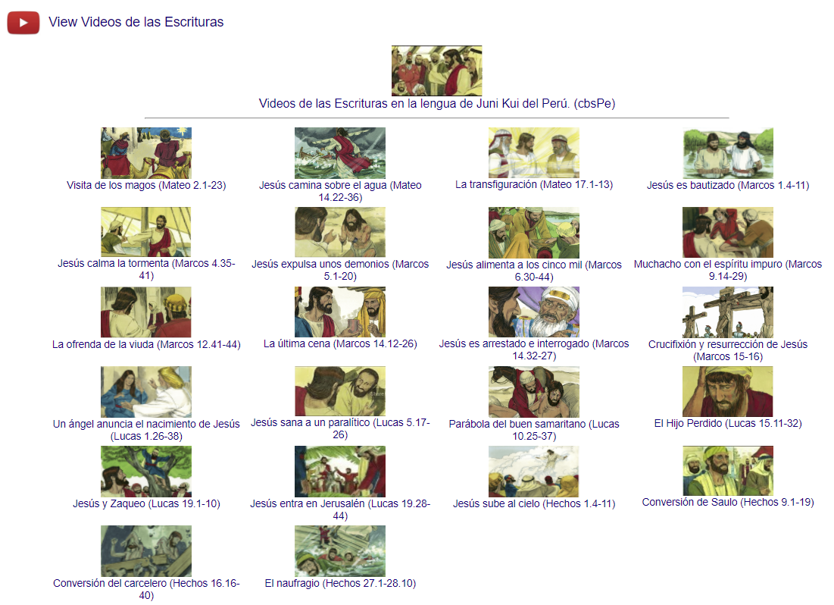

If you click on a thumbnail image, you will be taken to YouTube to watch the video.

Click **Download Videos de las Escrituras** to see the list of videos available to download.

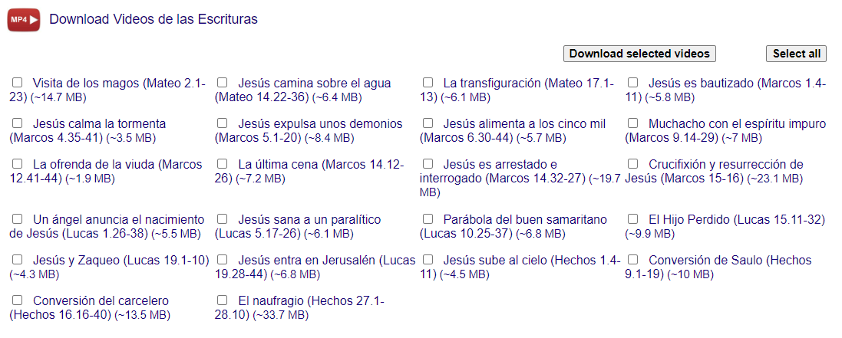

You can select several videos (or all of them) and download them as a zip file.